**FISH GAME**

**Problem Statement**

How to create Fish Game by just using simple HTML, CSS and JavaScript.

**Requirements**

* Should have basic knowledge about HTML and CSS.
* Should have good knowledge about JavaScript.

**Technologies Used**

* Web technology (HTML, CSS and JavaScript)
* Cloud Computing (AWS and Apache webserver for hosting the site)

**Project Description**

We have created a very nice and pretty game, which is very smooth to play. It has some characters which has their own role in this game.

* **Red Fish**
* This is our very first character also the main character of this game, which will play Vittel role in this game.

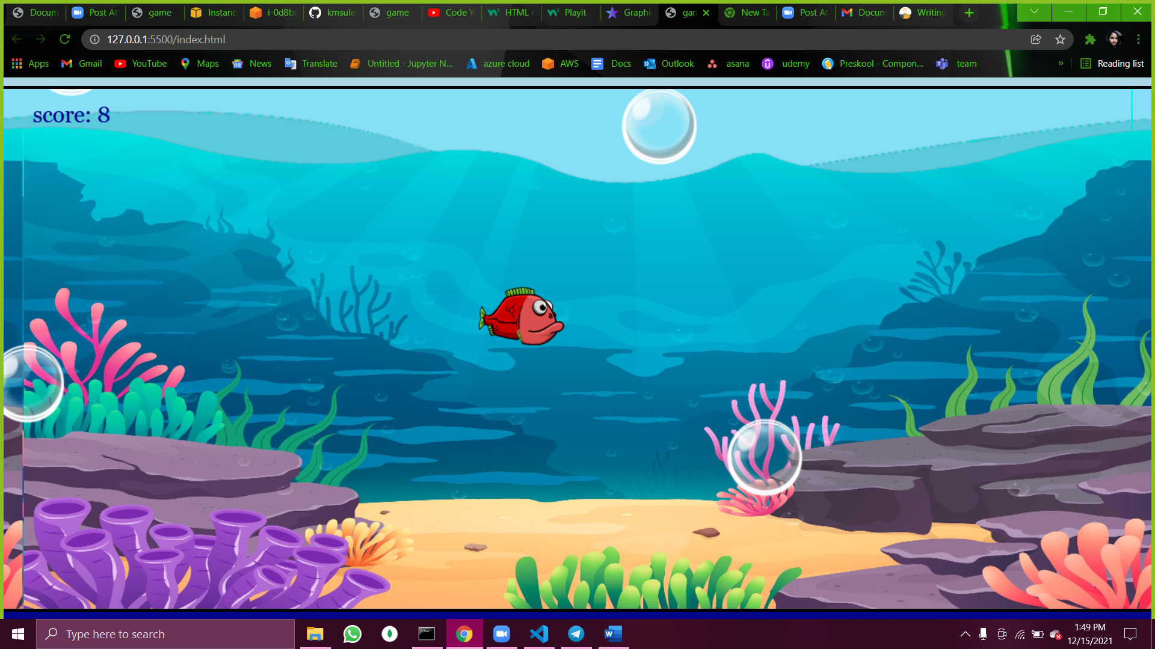

* This fish is animated character which will float into the water. It has two side left swim and right swim, if the mouse direction is left then left fish will swim if the mouse direction is right then right fish will swim and a little animated feathers which is really giving a very nice touch to this game.
* **Yellow Fish**
* This yellow fish is second character of this game which is going to create difficulties to reach out to the maximum score.

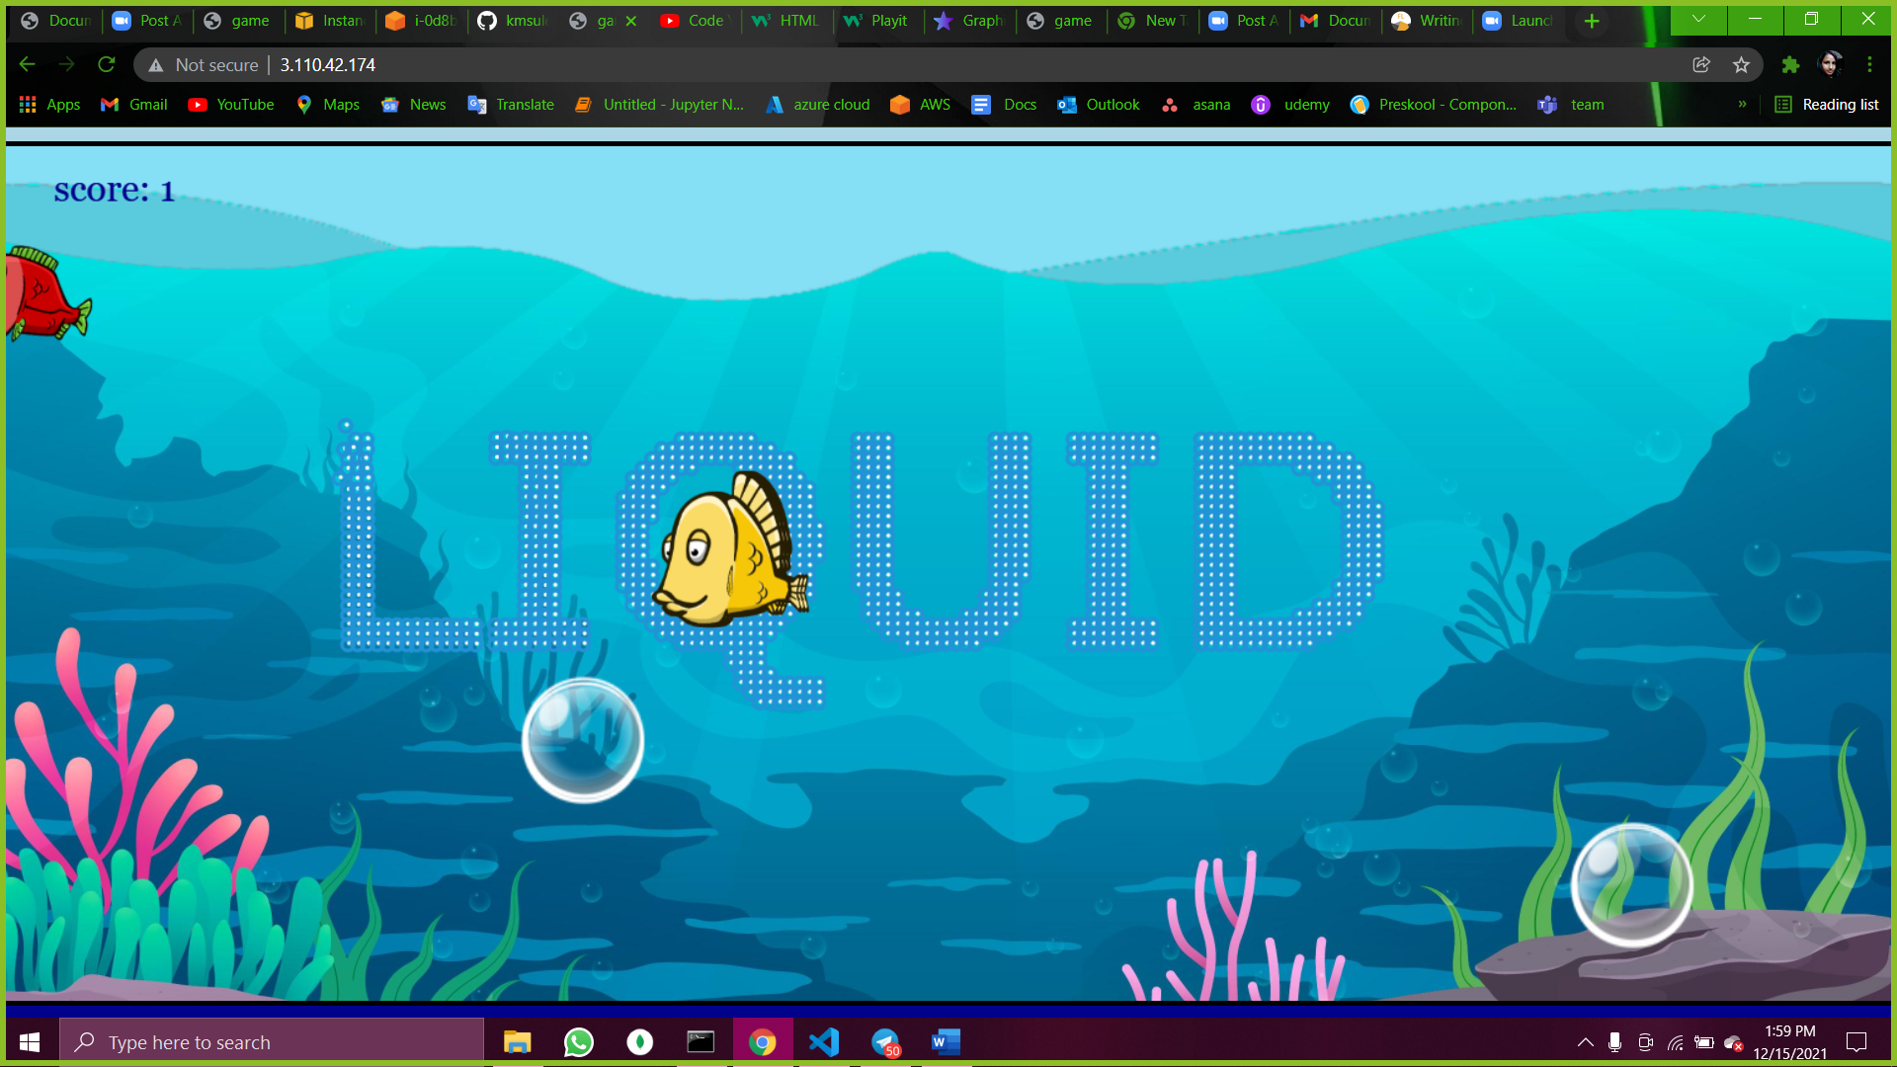

* Yellow fish is a animated character which will float right to left into the water.
* It has random initialization state which means no body can predict next time from where fish will come.
* **Bubbles**
* Next character is Bubble, if Red fish will collide with this bubble then score board will increase every time by one.
* These bubbles are very animated and dynamic. we cannot predict the initial state of these bubbles.

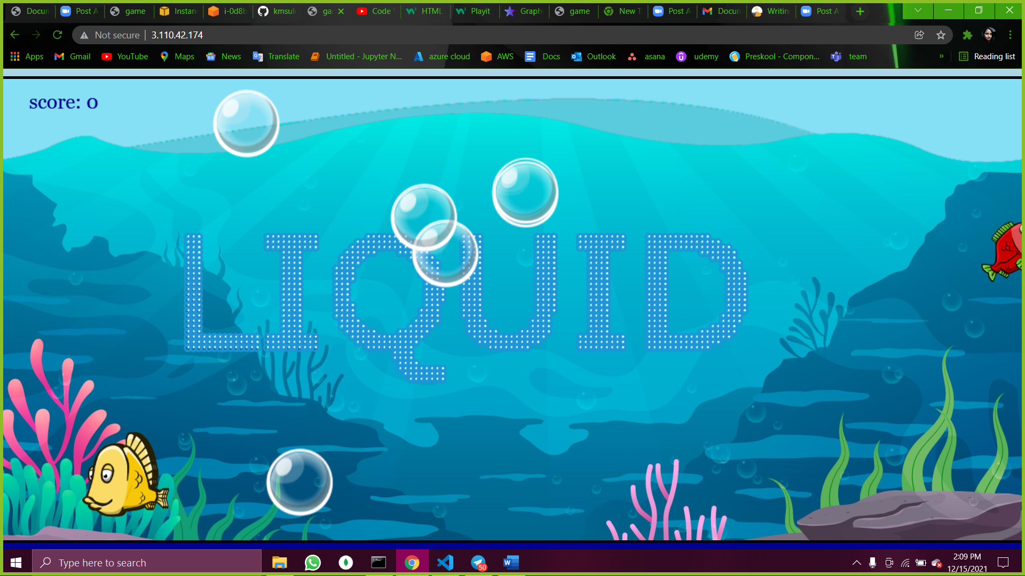

**Scope (Features and Functions of the Project)**

* This is very simple Web UI project which is purely made with just using simple HTML, CSS and JavaScript. Our Project is hosted over AWS Cloud and running inside Apache Webserver.
* Background is animated and floating. It gives real and amazing feels like real scenario.
* You can control Red Fish movement just by doing movement of your mouse curser.
* Bubbles are appearing dynamically (without having fixed position)
* Yellow fish is working as a Enemy role. If your fish touched with it so Game will be END.
* Once you bubbles popped it created amazing popped like sound.

**Challenges Faced**

* We have added floating background in the game which was little bit challenging part.
* Bubbles are coming dynamically from anywhere without a fix position which was bit complex.
* When we move fish on to the bubble it should be burst.
* Movement of red fish was little bit harder because it’s face should be turned around the direction of pointer of mouse.

**Conclusion**

This is always good if you create anything by just learning small-small things. It looks that its very harder to create Game just by using HTML, CSS and JavaScript because nowadays guys are using Framework instead of using just simple web. This Hackathon make me understand about how to utilize our time in best possible way and come out to be batter result in very short duration.